Name: Akhilesh Munishwar
PRN: 1262242269
Roll no.: 2
Panel: G

School of Computer Science and Engineering
Department of Computer Engineering and Technology
T. Y. B. Tech CSE
AY 2026-27 Semester V
Computer Networks Lab (CSE20110)
Assignment No.: 3
Title: Subnetting
Aim: Subnetting Use Packet Tracer
Write a program to demonstrate Subnetting and find subnet masks.
Objectives:
- To understand and learn the concept of IP address, subnet mask and subnetting.
Theory:
i) Internet Protocol (IP: IPv4 & IPv6)
The Internet Protocol (IP) is responsible for addressing and routing data packets so that they can travel across networks and reach the correct destination device. Every device on a network is assigned a unique IP address that identifies it, similar to how a postal address identifies a house.
IPv4 (Internet Protocol version 4) is a 32-bit address, usually written as four decimal numbers separated by dots (dotted-decimal notation), where each number ranges from 0 to 255. For example, 192.168.1.10 is a valid IPv4 address. IPv4 provides about 4.3 billion unique addresses, which is no longer sufficient for the number of devices connected to the internet today.
IPv6 (Internet Protocol version 6) is a 128-bit address, written as eight groups of four hexadecimal digits separated by colons. For example, 2001:0db8:85a3:0000:0000:8a2e:0370:7334 is a valid IPv6 address. IPv6 was introduced to overcome the address exhaustion problem of IPv4 and provides an extremely large address space, along with built-in support for security and simplified header structure.
ii) Classful Addressing Details
Classful addressing divides the IPv4 address space into five classes (A to E), each identified by the value of the first few bits of the address. Classes A, B, and C are used for regular unicast addressing, Class D is reserved for multicast, and Class E is reserved for experimental use. The table below summarizes the range, default subnet mask, and address capacity of each class.
Class | First Octet Range | Default Subnet Mask | No. of Networks | Hosts per Network
A | 1 – 126 | 255.0.0.0 | 126 | 16,777,214
B | 128 – 191 | 255.255.0.0 | 16,384 | 65,534
C | 192 – 223 | 255.255.255.0 | 2,097,152 | 254
D (Multicast) | 224 – 239 | Not applicable | — | —
E (Experimental) | 240 – 255 | Not applicable | — | —

iii) Networks and Hosts-per-Subnet Calculation
The number of networks and hosts available depends on how many bits are used for the network portion and how many are left for the host portion of an address. For a given number of borrowed/host bits, the calculations are:
- Number of subnets = 2^n, where n is the number of bits borrowed from the host portion for subnetting.
- Number of hosts per subnet = 2^h − 2, where h is the number of remaining host bits. Two addresses are subtracted because the first address of a subnet is reserved as the network address and the last is reserved as the broadcast address.
Example: Consider the network 192.168.1.0/26. This is a Class C network with 2 bits borrowed for subnetting (since the default Class C mask is /24 and here it is /26).
- Number of subnets = 2^2 = 4
- Number of hosts per subnet = 2^6 − 2 = 62
This means the /26 mask (255.255.255.192) divides the original network into 4 subnets, each capable of supporting 62 usable host addresses.
iv) Subnetting Concept — Example
Subnetting is the process of dividing a single large network into smaller sub-networks (subnets) by borrowing bits from the host portion of an IP address and using them for the network portion. This helps in efficient utilization of IP addresses, better network organization, reduced broadcast traffic, and improved security since each subnet can be isolated and managed separately.
Example: Take the network address 192.168.10.0/25. Since a Class C network is normally /24, borrowing 1 bit for subnetting (making it /25) gives:
- Subnet mask: 255.255.255.128
- Number of subnets = 2^1 = 2
- Number of hosts per subnet = 2^7 − 2 = 126
The two resulting subnets, along with their network address, broadcast address, and valid host range, are shown below.
Subnet | Network Address | Broadcast Address | Valid Host Range
Subnet 1 | 192.168.10.0 | 192.168.10.127 | 192.168.10.1 – 192.168.10.126
Subnet 2 | 192.168.10.128 | 192.168.10.255 | 192.168.10.129 – 192.168.10.254

Design Screenshots:
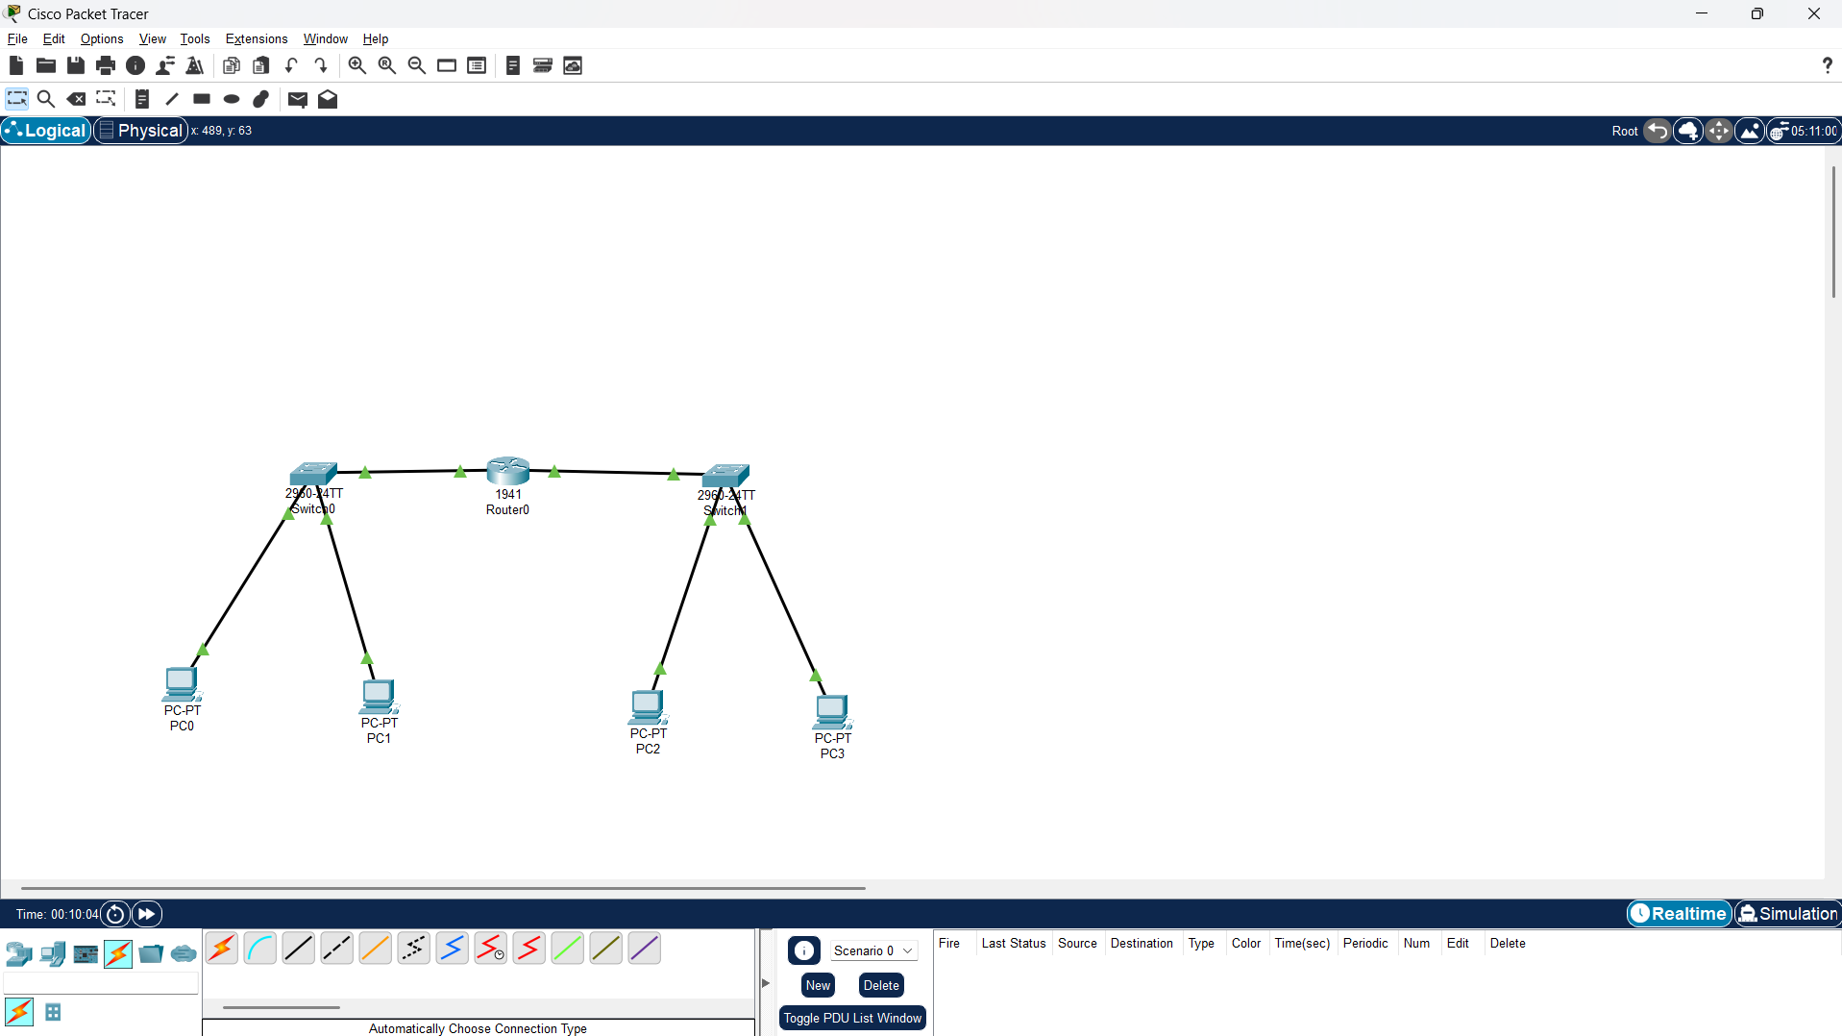
Steps of Execution:
- Select TWO switches each having 3 Hosts.
- Connect this two switches with Router.
- Transmit data from one network to second network.
Output Screenshots:

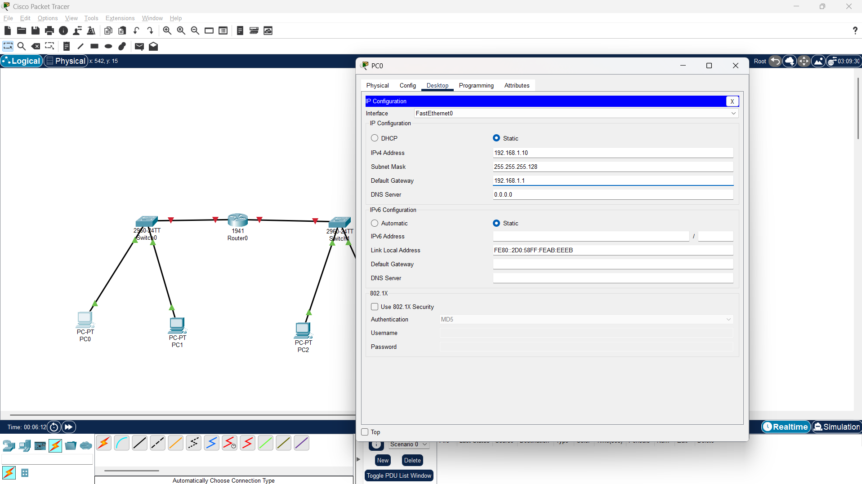

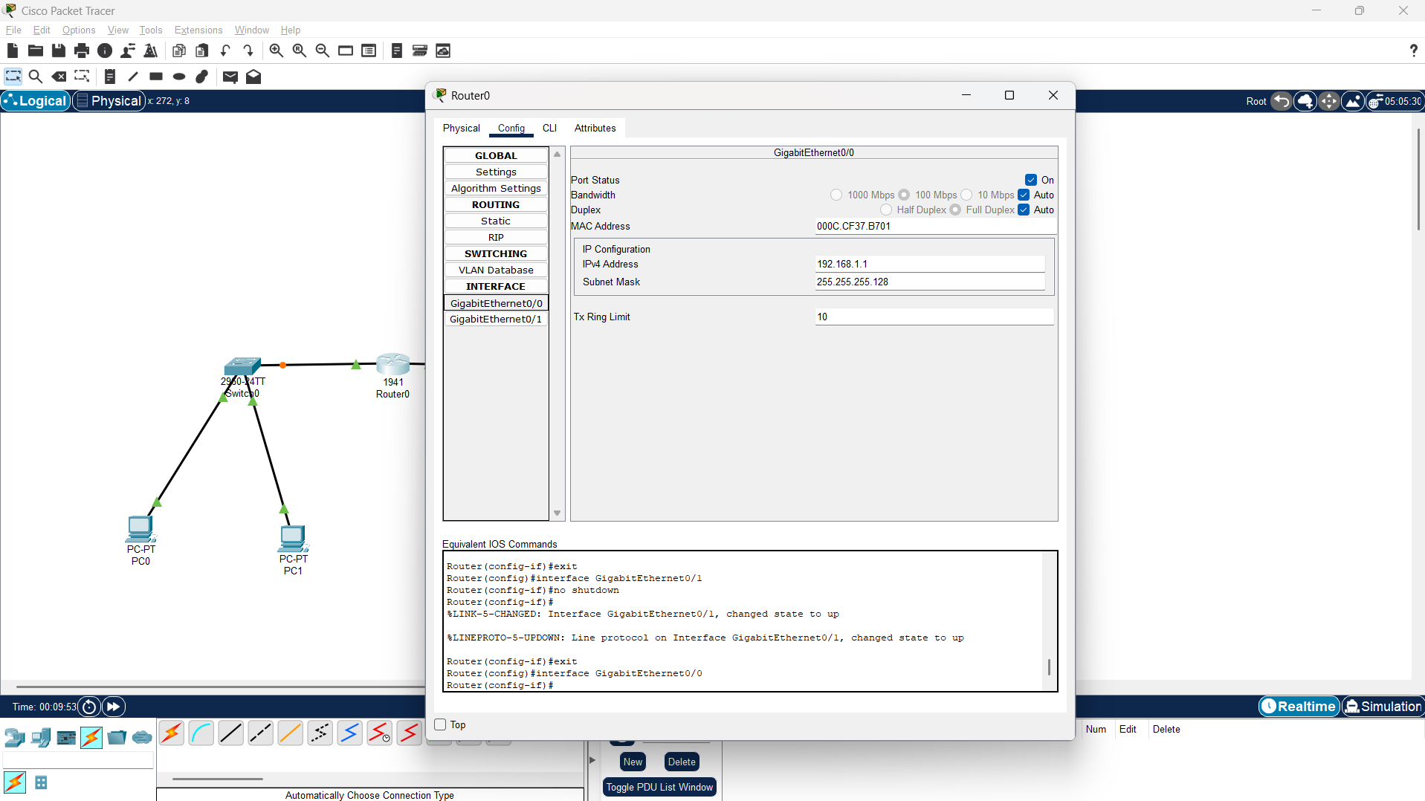

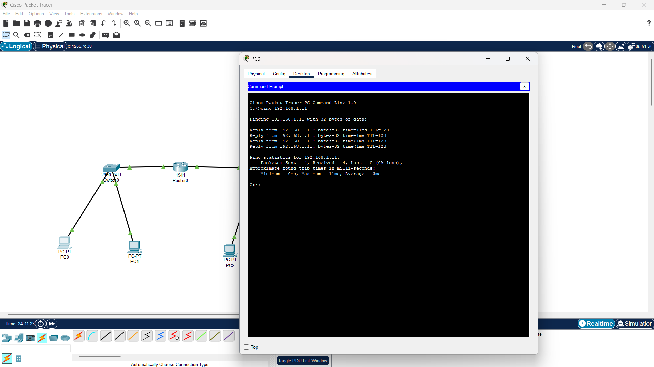

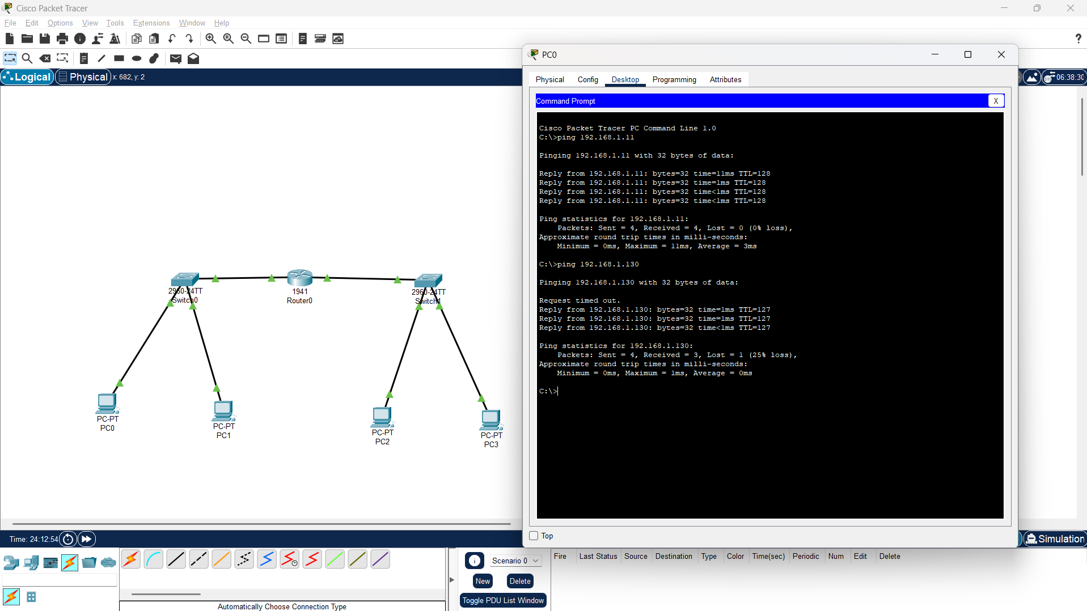
Students Observation:
In this assignment, we successfully demonstrated the concept of subnetting and IP address management using Cisco Packet Tracer. By configuring a network topology consisting of two switches each connected to three hosts and routing traffic between them using a central router, we practically observed how subnetting divides a single large network into smaller, manageable logical subnets.

FAQ:
1) Describe IP Addressing schemes with examples.
IP addressing schemes define how addresses are assigned and structured within a network. There are two broad addressing schemes:
- Classful Addressing: The IPv4 address space is divided into fixed classes (A, B, C, D, E), each with a predetermined network and host portion. For example, in Class C address 192.168.1.10, the first three octets (192.168.1) represent the network and the last octet (10) represents the host. This scheme is simple but wastes addresses since the class boundaries are rigid.
- Classless Addressing (CIDR): Classless Inter-Domain Routing removes the fixed class boundaries and allows the network/host split to occur at any bit position, denoted by a prefix length such as /24 or /27. For example, 192.168.1.0/27 indicates that the first 27 bits form the network portion, allowing much more flexible and efficient allocation of addresses than classful addressing.
2) What are different special/reserved IPv4 addresses?
Certain IPv4 addresses and ranges are reserved for special purposes and cannot be assigned to regular hosts on the public internet. The table below lists the commonly used reserved addresses.
Address / Range | Purpose
0.0.0.0 | Represents an unknown or unspecified source address.
127.0.0.0 – 127.255.255.255 | Loopback addresses, used by a host to test its own network stack (e.g., 127.0.0.1).
10.0.0.0 – 10.255.255.255 | Private address range (Class A) used within private LANs.
172.16.0.0 – 172.31.255.255 | Private address range (Class B) used within private LANs.
192.168.0.0 – 192.168.255.255 | Private address range (Class C) used within private LANs.
169.254.0.0 – 169.254.255.255 | Link-local (APIPA) addresses, auto-assigned when DHCP is unavailable.
255.255.255.255 | Limited broadcast address for the local network.

3) What is subnetting? Explain the use of subnetting with an example.
Subnetting is the technique of dividing a single large IP network into multiple smaller sub-networks (subnets) by borrowing bits from the host portion of the address for additional network bits. Instead of a large network wasting address space and creating a huge broadcast domain, subnetting breaks it into smaller, more manageable segments. This improves address utilization, makes routing more efficient, reduces broadcast traffic, and helps in isolating and securing different parts of a network (for example, separating a department's LAN from another's).
Example: A company is given the network 192.168.1.0/24, which supports 254 hosts. If the company has three departments, each needing only about 50 hosts, allocating the entire /24 network to each department would be wasteful. By subnetting the network into /26 blocks (255.255.255.192), it is split into 4 subnets of 62 usable hosts each — enough for each department, while making efficient use of the available address space.
4) In this IP address 192.168.10.0/25 —
The address 192.168.10.0/25 is a Class C network with 1 bit borrowed for subnetting (the default Class C mask is /24). The subnet mask for /25 is 255.255.255.128.
a. How many subnets?
Number of subnets = 2^1 = 2 subnets.
b. How many hosts per subnet?
Number of hosts per subnet = 2^7 − 2 = 126 usable hosts.
c. What are the valid subnets?
- 192.168.10.0
- 192.168.10.128
d. What's the broadcast address for each subnet?
- Subnet 192.168.10.0 → Broadcast address: 192.168.10.127
- Subnet 192.168.10.128 → Broadcast address: 192.168.10.255
e. What are the valid hosts?
- Subnet 192.168.10.0: Valid hosts from 192.168.10.1 to 192.168.10.126
- Subnet 192.168.10.128: Valid hosts from 192.168.10.129 to 192.168.10.254

